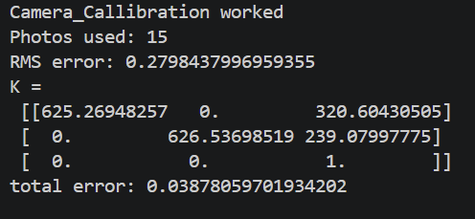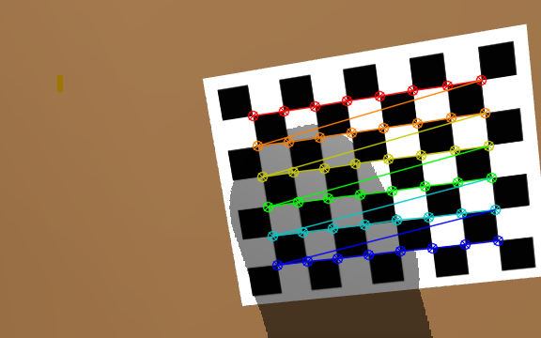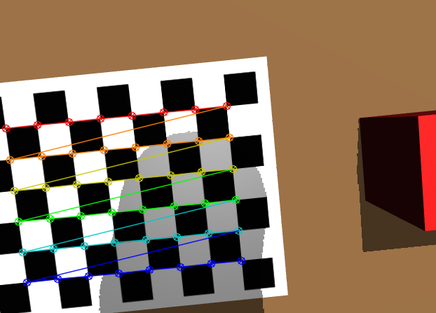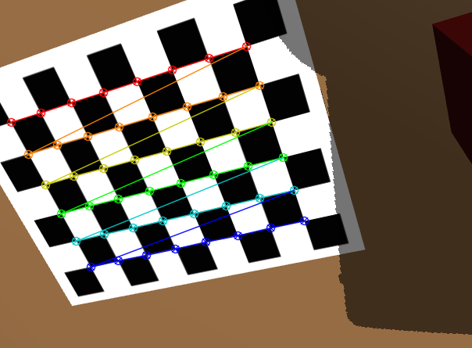

The perception pipeline converts each red-pixel measurement (u, v, d) into a 3D point using the camera intrinsic matrix K, so the accuracy of K directly affects the estimated position of the cube. The board placed in the MuJoCo scene has 9x7 squares, having 8x6 inner corners of 15mm squares. The arm was moved to random poses near its home configuration, and the first 15 images in which the full board was visible were kept. Corners were detected with OpenCV’s findChessboardCorners, refined to sub-pixel accuracy with cornerSubPix, which was used to estimate K withcalibrateCamera, adapted from the calibration tutorial. Finally, lens distortion was fixed at zero, as MuJoCo renders an ideal pinhole camera, fitting distortion parameters would only absorb noise and bias the focal length.
https://docs.opencv.org/3.4.20/dc/dbb/tutorial_py_calibration.html

Through analysis of the figures above, the calibration results are summarised in Table B1. The calibrated intrinsics achieved a reprojection error of 0.28 px. This means, the predicted corners land, on average, under a third of a pixel from the detected ones. More views with greater tilt variation would be expected to reduce the error further. 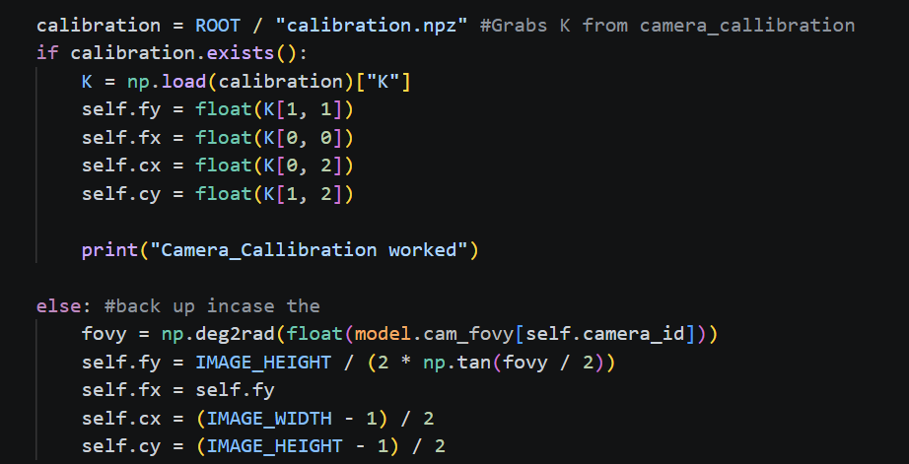
Variable | Sum | Error
Fx | 625.27-625.22 | 0.05px
Fy | 626.54-625.22 | 1.32px
Cx | 320.60-319.5 | 1.10px
Cy | 239.08-239.5 | 0.42px

The ground-truth intrinsics, derived from the simulated camera (fovy=42degrees), using f = (H/2)/tan, gives the results (fovy/2) = 625.2px, as shown in the fallback block of code above. The calibrated focal lengths have an error of 0.05px (fx) and 1.32px (fy) of the ground truth, and the principal is within 1.1px (cx) and 0.4px (cy). The larger error in fy may be due to less vertical tilt variety between the 15 point views, as all images were taken with the camera pointing down. To reduce this bias in fy the tilt diversity could increased by capturing new calibration images in which the pitch axis is rotated further. Finally, varying the distance between the camera and the board across more than the 15 views would give the algorithm better geometric leverage, as it will produce less biased focal lengths.

